KOREA WINE & SPIRITS AWARDS OVERVIEW

Korea Wine & Spirits Award 2023 schedule
September 2022. Guide (2023) distribution.
December 2022. Start to register applications.
January 2023. Application deadline
February 2023. fair In March. Awards ceremony, Business tasting

Contact. award@chosunbiz.com

- Introduction

Welcome to ‘Korea Wine & Spirits Award 2022.’

Each year, South Korea’s alcohol beverage industry dynamics is becoming more interesting than ever. Continuous growth of import scale on global alcoholic beverages and traditional industry players’ effort to keep domestic brands competitive in the market have fruited an unique industry scene.

Among such distinctive features in the industry, South Korean consumers' preference toward liquor brands has become much more diverse than they did in the past. Now, both global and domestic liquor from various categories including bai jiu, beer, saké, soju, spirit, traditional Korean alcoholic beverages, whiskey, wine and many more, are all enjoyed throughout every level of South Korean society.

To further encourage the growth of the South Korean liquor industry, ChosunBiz has been annually hosting KWSA since 2014 to introduce a variety of global/domestic alcoholic beverage brands to South Korean society. Also, KWSA set out a mission to discover/introduce unfamiliar brand products to the public. Due to such effort, the number of award participants was able to grow each year and by 2021, over 129 companies have submitted 659 product brands for the competition.

Now, KWSA is regarded as one of the most prestigious awards/festivals in the South Korean liquor industry scene. This was achieved by industry representatives from liquor production, logistics, distribution, promotion, influencers and enthusiasts that have been invited to the event through Chosun Media Group’s network over the years. Event programs such as award ceremonies and business tasting have also created an open on/offline community amongst such a crowd, exhibiting prestigious products that have won the award to the public as well.

Through the Korea Wine & Spirits Award 2022, ChosunBiz aims to constantly find/introduce higher quality liquor brand products and promote a healthy drinking culture. We sincerely hope alcohol beverage industry associates around the world share our enthusiasm with lots of interest and participation.

Host l ChosunBiz
Partners l Sensometrics, Wine21.com, WSA Wine Academy, Breworx Academy
Sponsor l
The Korean Food Professional Engineers Association, Institute of Traditional Korean Food, Korean Makgeolli Association, Korean Traditional Liquor Association, Sommelier Association of Korea, KISA, Korea Wine Association, Korea Wine Production Association, Whisky Society of Korea, ABA Korea, Korea Craft Brewers Association
Award Ceremony l
Friday, 11 March 2022, Grand Ballroom, The Westin Josun Hotel, Seoul, Republic of Korea(may change due to COVID-19)

2. Award Categories
Traditional Korean Alcohol | Distilled Drinks, Fruit Wine, Korean Wine, Liqueur, Takju Pasteurized Rice Wine(Takju Pasteurized Makgeolli), Takju Raw Rice Wine(Takju Raw Makgeolli), Yakju/Chungju
Soju | Diluted, Distilled, Fruit
Beer | Craft, Imported, Regular, Others
Whiskey | Blended, Blended Grain, Blended Malt, Low-Alcohol, Single Grain, Single Malt
Spirit | Brandy, Gin, Liqueur, Rum, Tequila, Vodka, Others
Bai Jiu | Regular(Below 80,000 KRW), Premium(80,000 KRW or Above)
Saké | Alcohol-Added, Japanese Soju, Namazake, Pure Rice
Wine | Fortified, Red(Old World, New World), Rosé, Sparkling, White(Old World, New World), Natural

3. Registration Process
Complete Registration  Forms | ➩ | Registration Fee Deposit  (Payment) | ➩ | Evaluations & Result Notifications | ➩ | Korea Wine & Spirits Award 2022
Download forms from website, then submit via E-mail or Fax |  | KRW 220,000 per entry brand  * VAT included  * Not per sample product |  | Evaluations & Grading sessions to select award-winning product brands by industry experts |  | Award Ceremony, Business Tasting, and Award-Winners Tasting sessions are scheduled

4. Evaluation Criteria
Flavour + Scent + Aftertaste(Finish) + Comprehensive Assessment
- Flavour: Evaluates entries’ balance between sweetness, sourness, bitterness and astringency
- Scent: Evaluates entries’ aroma
- Aftertaste(Finish): Evaluates entries’ body and texture on palate/throat
- Comprehensive Assessment: Evaluates entries’ overall balance and degree of colorization, turbidity, effervescence, and etc.

Evaluation Methods
* Evaluation Criteria: Each entry product is appropriately evaluated by criteria that differ by categories

* Blind Tasting: All entry products are covered with cloths for anonymity, but some category’s judge panels will be provided with sufficient product information that are needed for accurate assessments(e.g: raw materials, and etc.)

* Tasting Glass: International-standardized tasting glasses are used after a thorough inspection for any possible contamination source, or moisture

* Judge Panels: Officials recommended by industry experts are invited as judge panels and shall remain undisclosed until all the evaluation process is over for fair evaluations

* Awards: Bestowed upon product brands that have received the highest evaluation score in respective categories

* Additional Regulations: After each evaluation, all judge panels are required to rinse their mouths with water and then proceed to the next evaluation under supervised on-site instructions

5. Entry Guidelines
ㆍSample Product Specifications: All entry products must be contained in glass bottles
ㆍ‘Beer’ and ‘Rice Wine’[Makgeolli] categories are not included
ㆍAll entry products’ manufacture dates must be within 7~30 days before the registration
submission date
ㆍQuantity: 4 sample product bottles per brand are required for entry submissions
ㆍ2 for tasting
ㆍ1 for exhibition(if awarded)
ㆍ1 for unexpected mishaps(e.g: shipment damage, and etc.)
ㆍStorage Information: For entries that require extra attention, please enclose storage information, or any guideline for a proper product management before the evaluation
ㆍ“Extra Attention” may include,
ㆍTemperature Check
ㆍRefrigeration Storage
ㆍProduct Fragility
ㆍAnd other possible environmental factors that may affect the entries
ㆍProduct Information: Please enclose product information on entries’ components and attributes
ㆍFormat-Free
ㆍFor fermented entry products, please use refrigerated containers or ice boxes to
prevent further acidification

6. How to Register
ㆍDeadline for Registration & Registration Fee Deposit: Wednesday, 9 February 2022
ㆍE-mail Registration: Download registration forms from our website(drink.chosunbiz.com), fill out the forms, then send them to our e-mail address listed below
ㆍFax Registration: Fill out written registration forms, then send them to our fax number listed below
ㆍReception & Inquiry
Administration Office, Korea Wine & Spirits Award 2022
Tel: +82-2-724-6157 Fax: +82-2-724-6098
E-mail: event@chosunbiz.com

7. Korea Wine & Spirits Award 2022 Winner Benefits

Promotion
1. Nation-Wide Special Coverage on Award-Winning Companies:
Award winners(product/brand/company) will be constantly featured on Chosun Media Group’s news articles throughout the rest of the year
- ‘Chosun Media Group’ is the largest, most influential, prestigious, and venerable
media group in South Korea since 1920
- ChosunBiz Online Subscribers: More than 2 Million
2. Award Emblems Will be Bestowed:
- Grand Award(Silver): brands that received high marks in their evaluation
- Best of the Best Award(Gold): brands that received the highest marks in their respective category
3. Special Award Emblems Will be Bestowed Upon Multiple-Time Winners:
- Multiple Winner Emblem(Silver): 3rd, 4th time award winners
- Multiple Winner Emblem(Gold): 5th time(or more) award winners
4. Will be Featured on ChosunBiz’s Liquor-Specialized Review Column, “Soon-wook Park’s Liquor Road”:
- ‘ChosunBiz’ is the business/economy-specialized media sector in Chosun Media Group since 2010
- Brands that have been already featured in the column shall not be covered again in this particular section
5. Promotion via ChosunBiz’s Social Media Channel:
- Facebook: 38,826 Followers
- YouTube: 9,630 Subscribers
- Instagram and more
6. Special Exhibition Promotions in South Korea’s Nationwide-Scale Megastores/Premium Liquor Stores:
- Partner store/retailer list will be disclosed to the public through official channels once finalized
- Tentative on the specifics due to COVID-19 pandemic at the moment
7. Will be Nominated as ChosunBiz’s Main Drinks
- Will be Utilized during Annual VIP Meetings & Gala Dinner held by ChosunBiz
- VIPs are as follows: C-level Global/Domestic Business Executives, Government Officials, Politicians, Media Representatives, Various Industry Experts, Keynote Speakers in ChosunBiz Annual Events, and more
8. Will be promoted online via official event website
- Award Winning Entries, Importers, Winery Brands and more

Business Tasting
1. Exhibition:
- Will be exhibited and introduced after the award ceremony for chances to discover new buyers and promote products
- If canceled due to COVID-19, the tasting will be held online with the consent of importers that still wishes to participate
2. Communication:
- Will be provided with various opportunities for communication with audiences that have attended the ceremony
- Communication purposes are as follows: Product Promotion, Brand Exposure, Widening Distribution Channel and more
- Audiences are as follows:Distributors, Importers, Manufacturers, Government Officials, Advocates and more
3. Charity Exposition for Advocates:
- Will be included in a tasting event held for drink advocates on the day of ceremony after all programs are over
- May be delayed, or canceled according to updated South Korean government’s COVID-19 quarantine guidelines

Information
- Except for the ‘Wine’ category, all the entries will be provided with reports including detailed analysis designed by an institution of sensory evaluation, even if they did not win the award
- Institution includes, Sensometrics, Wine21.com, WSA Wine Academy, Breworx Academy with product assessment results from judge panels as evaluation criteria

8. Images

Award Emblems(Stickers)
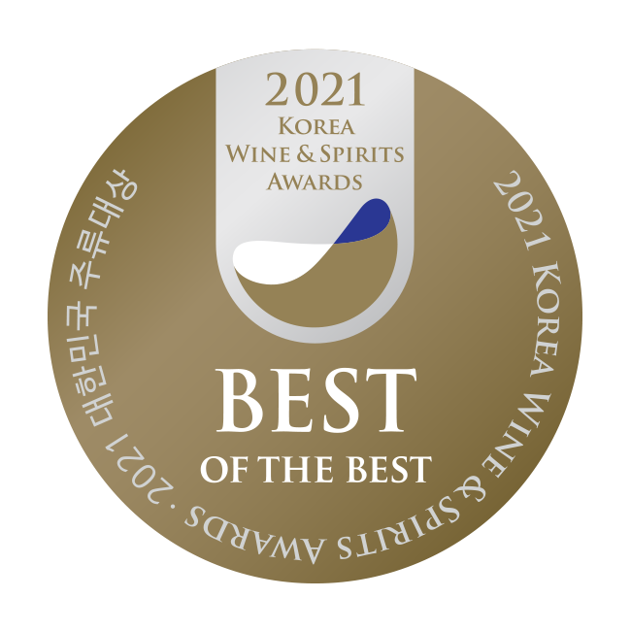
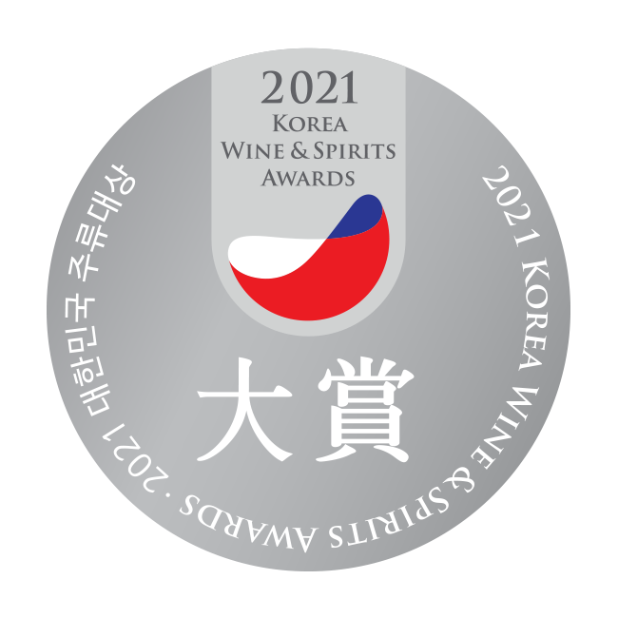

Evaluation Analysis Report | Soon-wook Park’s Liquor Road
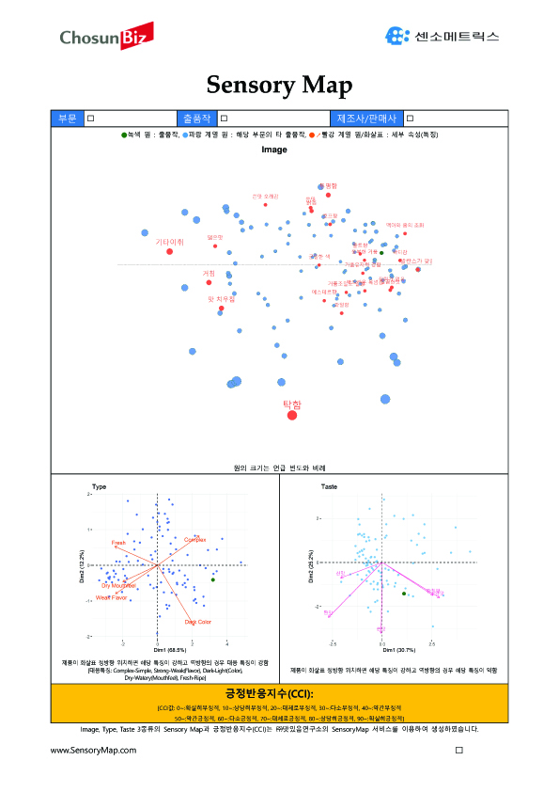 | 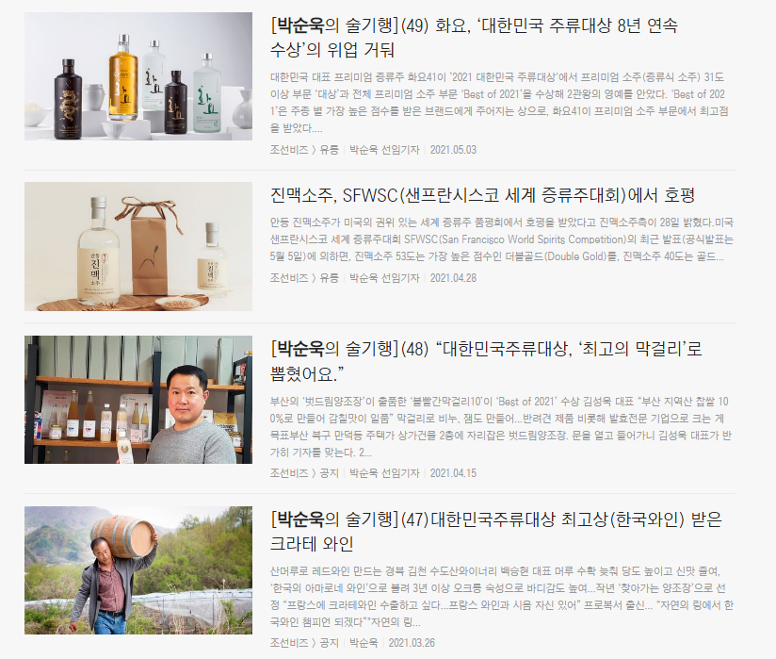

KWSA Evaluation & Grading Sessions
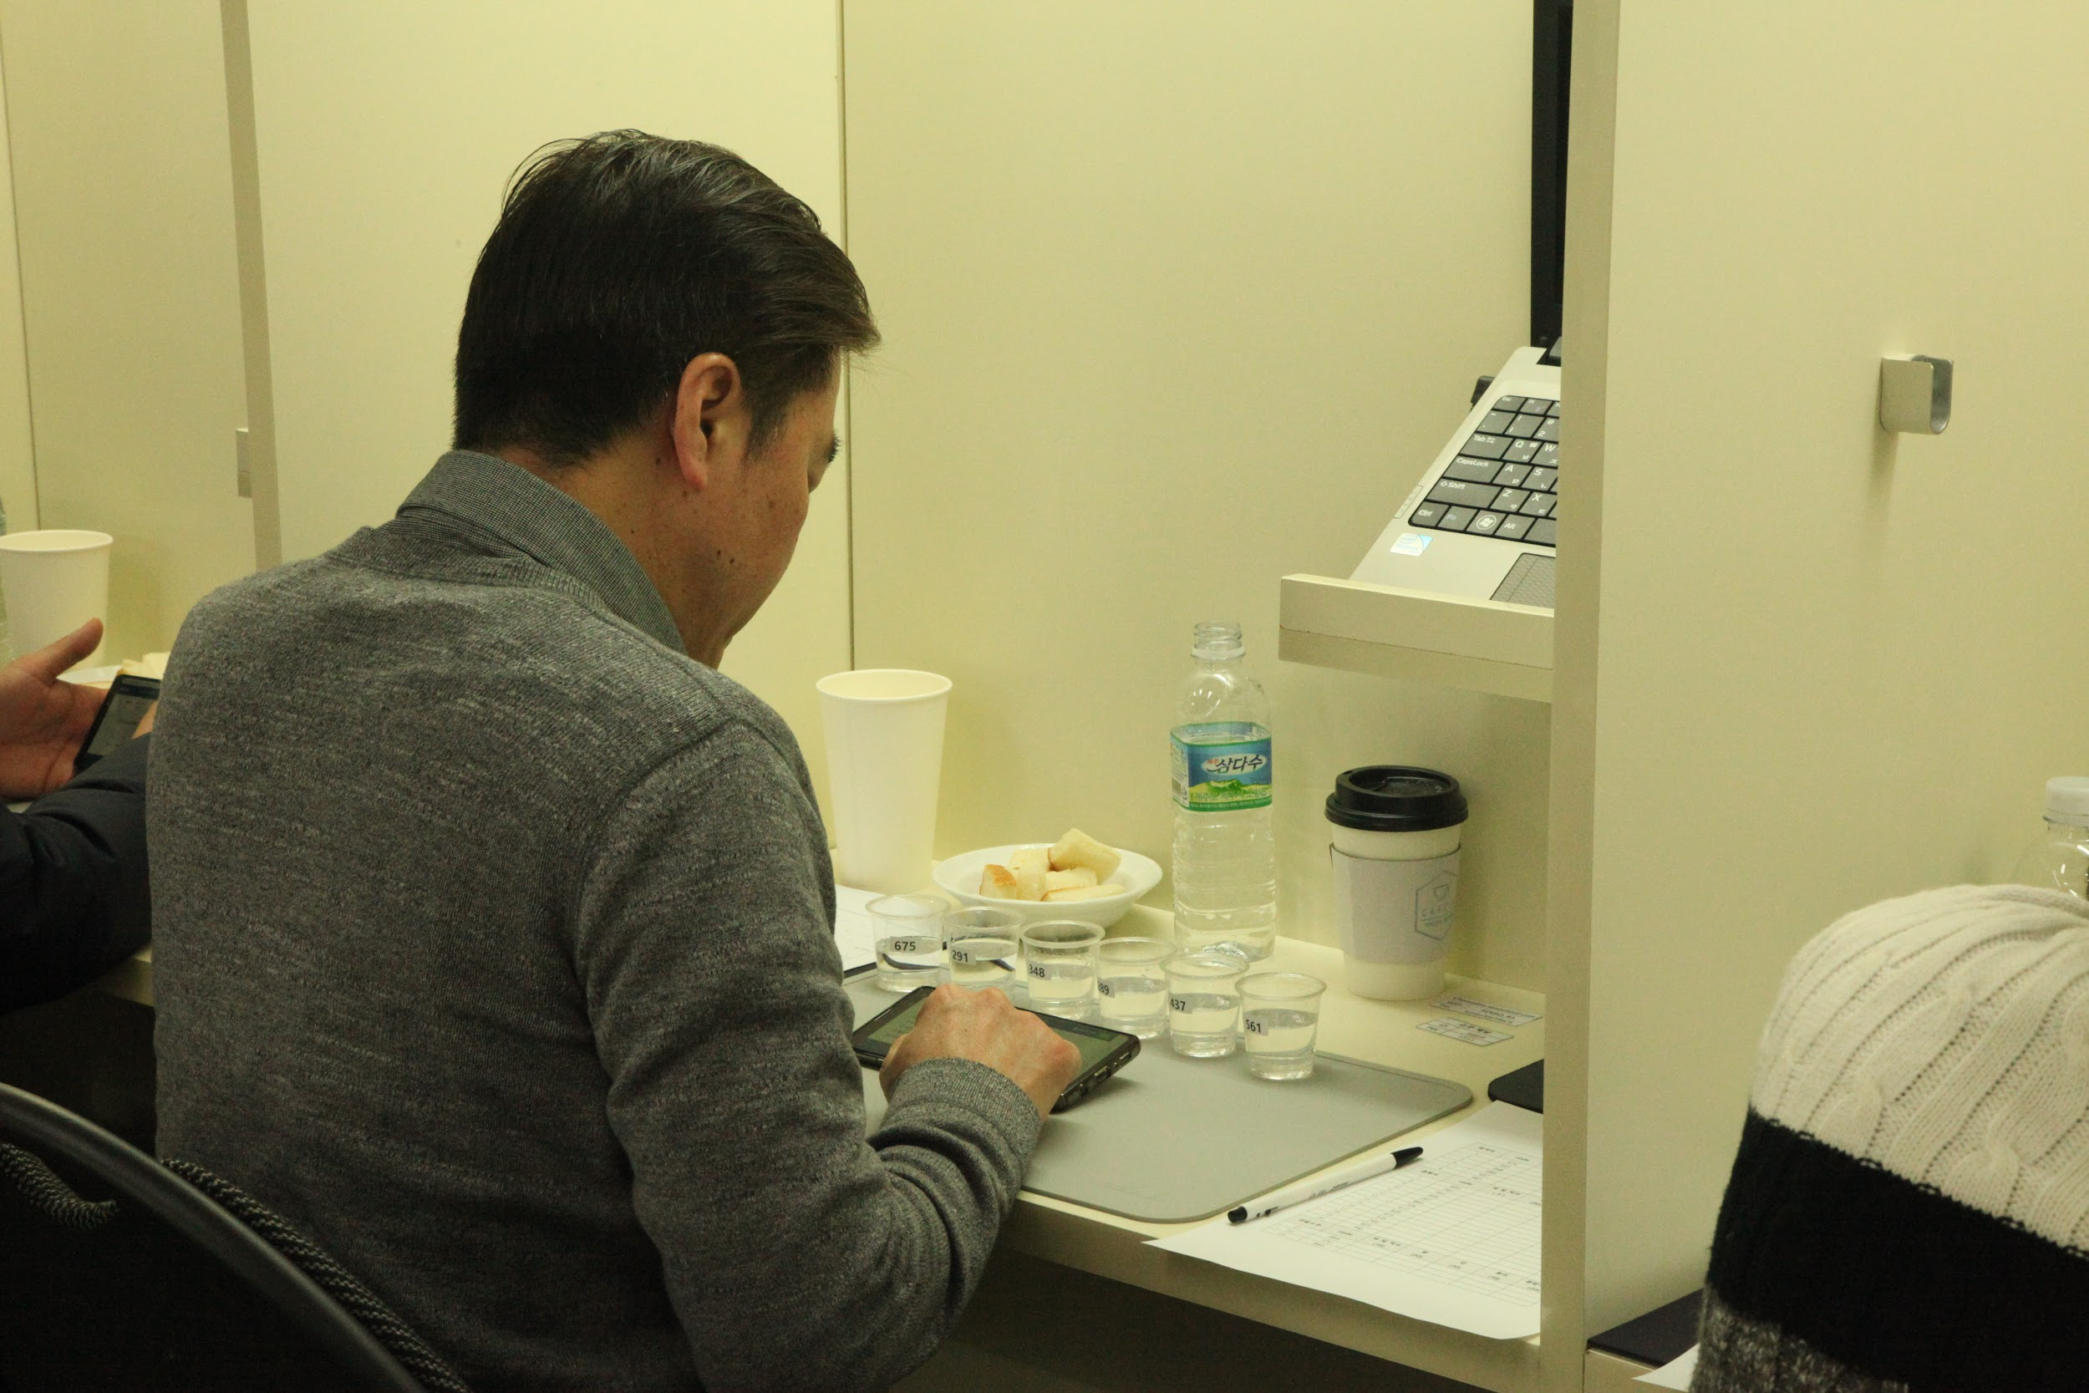  Sensometrics(2 Feb. 2021) | 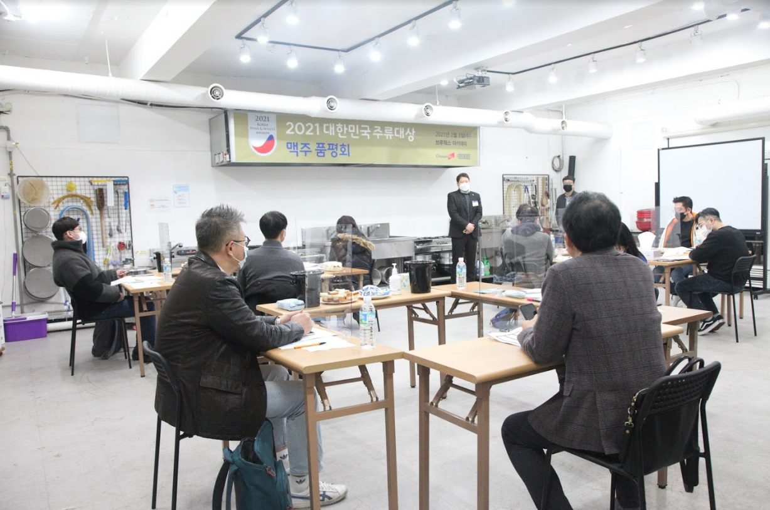  Breworx(3 Feb. 2021)
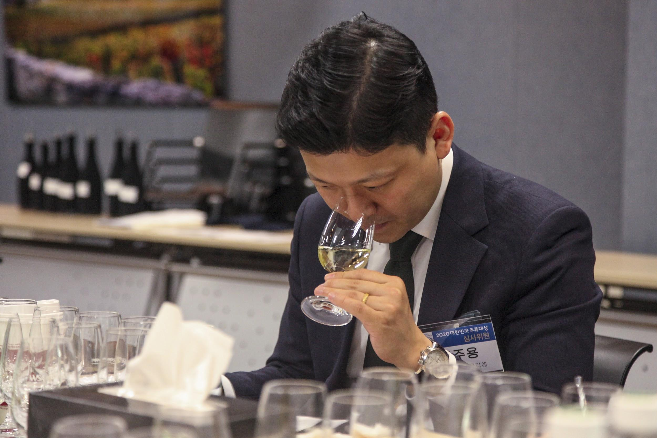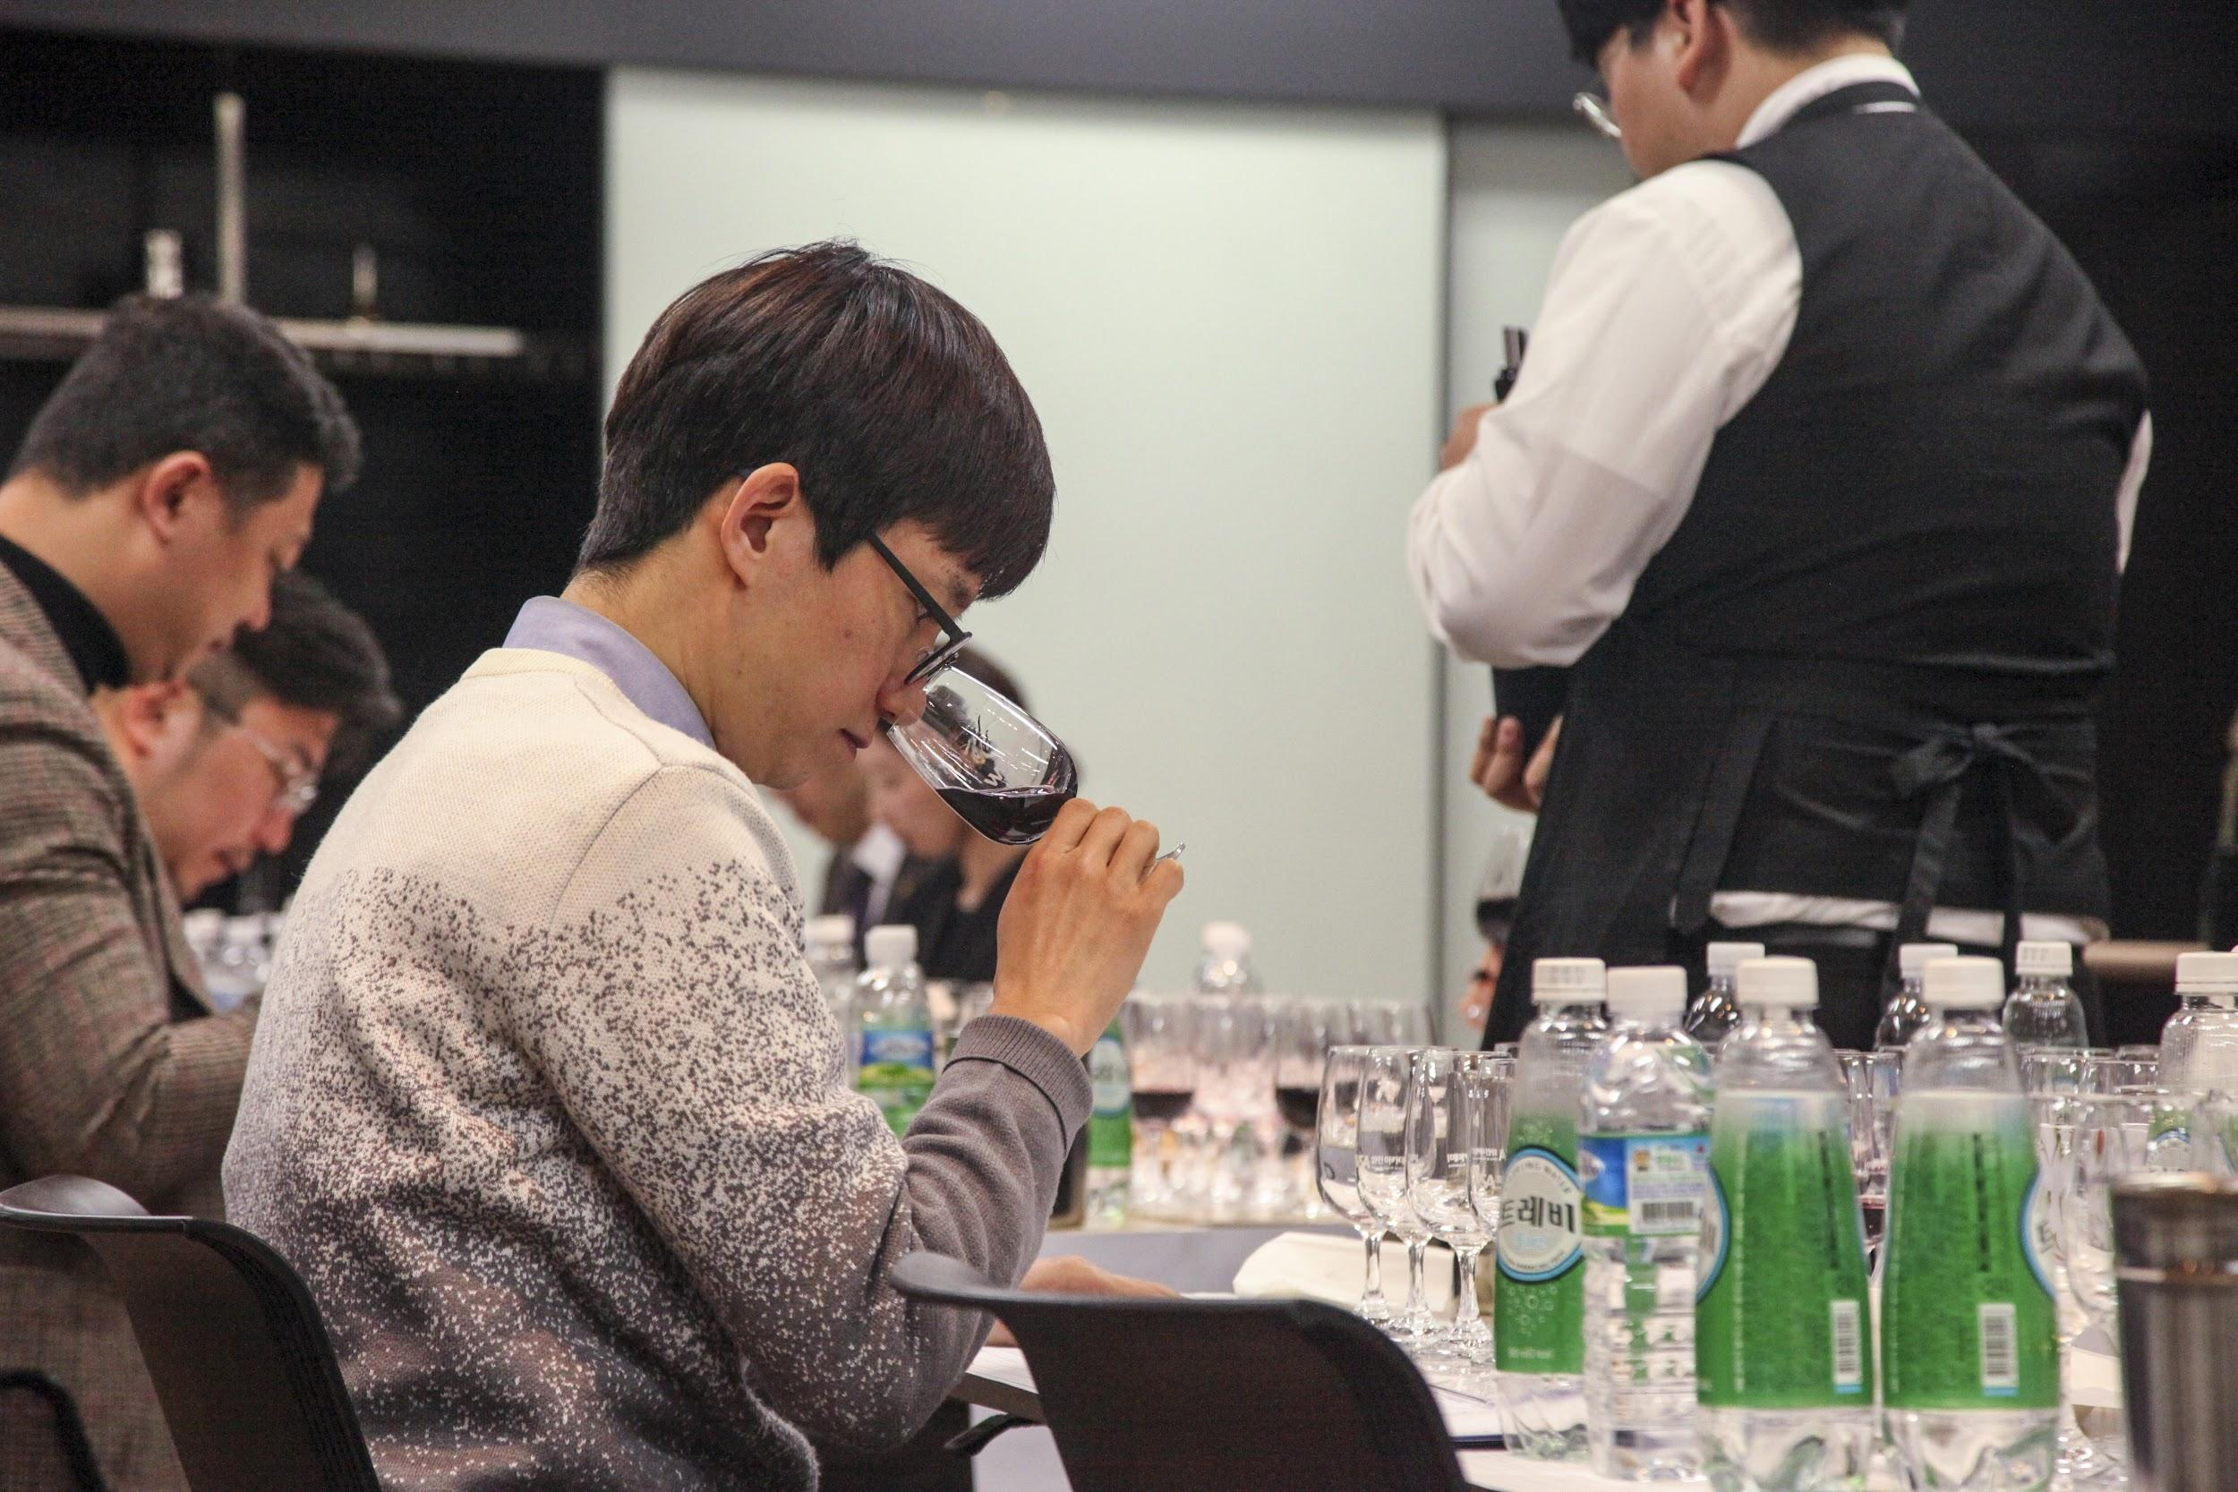
WSA Wine Academy(4 Feb. 2021)

Korea Wine & Spirits Award 2022 Entry Regulations

[1] Definition of Terms
1) Term “Participant” refers to alcohol beverage companies and importers that have completed the registration for Korea Wine & Spirits Award 2022.
2) Term “Host” refers to ChosunBiz.

[2] Registration & Fee Deposit
1) A company that wishes to register for the Korea Wine & Spirits Award must fill out registration forms and submit them to ChosunBiz Administration/Executive Office via Fax or E-mail.
2) Registration is not completed until all the registration forms, entry samples, registration fees, and all the other required documents (such as product information) are submitted and paid in full.
3) A participant must immediately notify the host of any changes made in the registration forms whenever it is made. When failed to do so, the participant shall be responsible for any disadvantages resulting from the changes made without such notifications.
4) A participant must pay the full registration fee within a week of the registration form submission and must pay it by Wednesday, 9 February 2022 at the latest.
5) A participant shall pay all the bank fees incurred during remittance.
6) A participant must write the company name in a depositor column during the remittance.
ㆍRegistration Fee: KRW 220,000 per brand (VAT included)
ㆍBeneficiary: ChosunBiz Inc.
ㆍBeneficiary Address: 5F, 135, Sejong-daero, Joong-gu, Seoul, Republic of Korea, 04519
ㆍSWIFT Code: CZNBKRSEXXX
ㆍAccount Number: 813037-04-003625
ㆍBeneficiary Bank Name: Kookmin Bank
ㆍBeneficiary Bank Address: 1F, 135, Sejong-daero, Joong-gu, Seoul, Republic of Korea, 04519

[3] Instructions for Entry
1) Registered ‘Beer’ and ‘Craft Beer’ category entries must arrive to the allocated reception between 11 February(Friday)~02:00 pm, 14 February(Monday). Registered ‘Wine’ category entries must arrive to the allocated reception on 14 February(Monday). The receptions will not receive entries during holidays and weekends.
2) Registered ‘Wine’ category entries must arrive to the allocated reception on 14 February(Monday) between 10:00 am~03:00 pm all together at once.
3) Registered ‘Traditional Korean Alcohol(Korean Wine included),’ ‘Soju,’ ‘Whiskey,’ ’Spirit,’ ‘Saké,’ and ‘Bai Jiu’ category entries must arrive to the allocated reception between 14 February(Monday)~03:00 pm, 16 February(Wednesday).
ㆍReceptions:
- Traditional Korean Alcohol(Korean Wine included), Soju, Whiskey, Spirit, Saké, and Bai Jiu Categories: Sensometrics Inc., 406, Geumgang Penterium IT Tower, 171, Dangsan-ro, Yeongdeungpo-gu, Seoul, Republic of Korea, 07217
- Beer and Craft Beer Categories: Breworx Academy, B1, Jungseo bldg, 985-2, Bangbae-dong, Seocho-gu, Seoul, Republic of Korea, 06704
- Wine Categories: WSA Wine Academy, 1F, Shinyoung bldg, 311, Shinbanpo-ro, Seocho-gu, Seoul, Republic of Korea, 06532
※ For Korean Wine, please ship entries to our Traditional Korean Alcohol reception.
4) Each product box should be attached with “Entry Registration Form for Korea Wine & Spirits Award 2022[for boxes]” as well as a copy of registration receipt and product information enclosed. Product information may be sent through attached files in E-mail.
5) The participant is responsible for any cost incurred during the shipment of entry products.
6) If an entry product does not arrive by the specified deadlines, the participant shall be solely responsible for the failure of registration completion and cannot be reimbursed.
7) If an entry product is damaged while being delivered/shipped, the host can request the participant to re-ship the sample for re-entry, and the participant can re-send the sample. All the cost incurred during the re-entry is the participant’s responsibility.

[4] Guidelines for Award Label Logo Usage
1) Korea Wine & Spirits Award 2022 winners will receive image files of the award label logo design.
2) The logos may be used on promotional products such as labels, banners, etc.
3) The image files and labels are provided only to the award-winning companies, and all other unauthorized modifications of the design or usages for non-promotional purposes are strictly prohibited.

[5] Criteria for Awards & Result Announcements
1) Entries will be graded for awards based on a scoring system.
2) Entries with the highest score in each category will receive the grand prize. However, if the highest scores in a category are inevitably tied, one or more entries may win the grand prize.
3) Even if the award is given to multiple entries in a category, a participant cannot argue with the outcome.
4) Evaluation scores and participant lists shall not be disclosed.
5) When a competition rate of an entry category is significantly lower than those of others, the category in discussion will be arbitrarily combined with another category based on suggestions made by judge panels.

[6] Cancellation & Refund(for Participants)
1) Registered entries and fees will not be returned or refunded, whether a participant has won the award or not.
2) However, should a participant request cancellation for the event within the registration period, the cancellation can be accepted, and remitted fees shall be reimbursed in full. Submitted entry products are not returned.
3) If a participant requests cancellation for the event after the registration period, registration for Korea Wine & Spirits Award can be cancelled. However, refunds and product returns will not be made in this case.

[7] Cancellation or Adjustments of Korea Wine & Spirits Award
1) Should the host cancel the Korea Wine & Spirits Award unilaterally, remitted fees will be reimbursed in full to participants. However, if the event is cancelled or adjusted on dates due to natural disasters or force majeure, the host is not responsible for the matter. Also, refunds and product returns will not be made in such cases.

-----------------------------------------------------------------------------------------------------------------------------------------

Korea Wine & Spirits Award 2022 Registration Form

1. Applicant Information
Company Name |  | Company  Representative
Person in Charge  of the Event |  | Title
Phone |  | Mobile
E-mail |  | Fax
Address |  | Website
Entry Type | □ Traditional Korean Alcohol □ Soju □ Beer □ Whiskey □ Spirit □ Wine □ Saké □ Bai Jiu

2. Registration Fee
Notice | KRW 220,000 per entry  (VAT included) | Number of Entries in Total
 |  | Fee in Total

3. Entry Drink Samples Guideline
Please Submit 4 Bottles per brand
(2 for Tasting, 1 for Exhibition_if awarded, and 1 for Unexpected Mishap)

4. Documents for Submission
A copy of Business Registration Certificate and Product Information

5. Deadlines
Registration Forms & Fee Deposit: Wednesday, 9 February 2022

Sample Submission
Beer/Craft Beer: 11 February 2022(Friday) ~ 02:00 pm, 14 February 2022(Monday)
※ The above is entry products’ arrival time in respective receptions in Seoul, South Korea

Traditional Korean Alcohol/Korean Wine/Soju/Whiskey/Spirit/Saké/Bai Jiu:
14 February 2022(Monday) ~ 03:00 pm, 16 February 2022(Wednesday)
※ The above is entry products’ arrival time in respective receptions in Seoul, South Korea

Wine : 10:00 am ~ 03:00 pm, 14 February 2022(Monday)
※ The above is entry products’ arrival time in respective receptions in Seoul, South Korea
※ Due to the difficulty in storage, the entry products must arrive to the reception only
during the stated time period above

[Sample Reception Address]
- Traditional Korean Alcohol(Korean Wine included), Soju, Whiskey, Spirit, Saké, and Bai Jiu Categories: Sensometrics Inc., 406, Geumgang Penterium IT Tower, 171, Dangsan-ro, Yeongdeungpo-gu, Seoul, Republic of Korea, 07217
- Beer and Craft Beer Categories: Breworx Academy, B1, Jungseo bldg, 985-2, Bangbae-dong, Seocho-gu, Seoul, Republic of Korea, 06704
- Wine Categories: WSA Wine Academy, 1F, Shinyoung bldg, 311, Shinbanpo-ro, Seocho-gu, Seoul, Republic of Korea, 06532
  - Wine Sample Registration Confirmation Contact:
Byun Yong Jin, Director, Executive Administration Office, Korea Wine & Spirits Award 2022
Mobile: +82-10-9161-4383

6. Additional Guidelines
Please fill in the entry registration form on the next page.
Attach the form to “Registration Form for Korea Wine & Spirits Award 2022.”
Send them to ChosunBiz via Fax or E-mail.
Fax: +82-2-724-6098, E-mail: award@chosunbiz.com.
Please enclose product information materials for submitted entries. (Format-free)

7. Payment Guidelines
- Registration Fee: KRW 220,000 per brand (VAT included)
- Beneficiary: ChosunBiz Inc.
- Beneficiary Address: 5F, 135, Sejong-daero, Joong-gu, Seoul, Republic of Korea, 04519
- SWIFT Code: CZNBKRSEXXX
- Account Number: 813037-04-003625
- Beneficiary Bank Name: Kookmin Bank
- Beneficiary Bank Address:
1F, 135, Sejong-daero, Joong-gu, Seoul, Republic of Korea, 04519
※During deposit, please write registering company name in depositor column.
For a tax invoice, please contact Korea Wine & Spirits Award 2022 Executive Administration
Office.

I agree with all terms of Korea Wine & Spirits Award 2022 as the above and register for the participation.

Date of Registration (Year/Month/Date) |  | Company Name
Participant’s Personnel in Charge |  | Signature

Korea Wine & Spirits Award 2022 Drink Classification Codes
T r a d i t i o n a l K o r e a n A l c o h o l |  |  | S p i r i t s |  | (Classification chartered by Spirits Selection)
A.a.1 | Takju | Raw Makgeolli Regular  (Regular License) | E.a.1 | Vodka | Standard  (Below 40,000 KRW)
A.a.2 |  | Raw Makgeolli Traditional  (Traditional, Local Special) | E.a.2 |  | Premium  (40,000 KRW or Above)
A.a.3 |  | Pasteurized Makgeolli Regular  (Regular License) | E.b.1 | Rum | Heavy
A.a.4 |  | Pasteurized Makgeolli Traditional  (Traditional, Local Special) | E.b.2 |  | Medium
A.b.1 | Yakju/Chungju | Regular  (Regular License) | E.b.3 |  | Light
A.b.2 |  | Traditional  (Traditional, Local Special) | E.c.1 | Gin
A.c.1 | Liqueur |  | E.d.1 | Tequila | White
A.d.1 | Fruit Wine |  | E.d.2 |  | Gold
A.e.1 | Korean Wine |  | E.e.1 | Brandy
A.f.1 | Distilled | Below 25% ABV | E.f.1 | Liqueur
A.f.2 |  | 25% ABV or Above,  Below 40% ABV | E.g.1 | Others
A.f.3 |  | 40% ABV or Above
A.g.1 | Others
S o j u
B.a.1 | Fruit
B.b.1 | Regular  (Diluted) | Below 17% ABV
B.b.2 |  | 17% ABV or Above,  Below 21% ABV
B.b.3 |  | 21% ABV or Above | W i n e
B.c.1 | Premium  (Distilled) | Below 26% ABV | F.a.1 | Red  (Old World) | Below 30,000 KRW
B.c.2 |  | 26% ABV or Above,  Below 31% ABV | F.a.2 |  | 30,000 KRW or Above,  Below 60,000 KRW
B.c.3 |  | 31% ABV or Above | F.a.3 |  | 60,000 KRW or Above,  Below 100,000 KRW
 |  |  | F.a.4 |  | 100,000 KRW or Above
 |  |  | F.b.1 | Red  (New World) | Below 30,000 KRW
B e e r |  | (Classification chartered by WBC STYLE) | F.b.2 |  | 30,000 KRW or Above,  Below 60,000 KRW
C.a | Regular  (Mass Produced) | Hybrid | F.b.3 |  | 60,000 KRW or Above,  Below 100,000 KRW
C.b |  | Lager | F.b.4 |  | 100,000 KRW or Above
C.c |  | Ale | F.c.1 | White  (Old World) | Below 30,000 KRW
 |  |  | F.c.2 |  | 30,000 KRW or Above,  Below 60,000 KRW
C.d | Craft  (Small-Volume) | Hybrid | F.c.3 |  | 60,000 KRW or Above,  Below 100,000 KRW
C.e |  | Lager | F.c.4 |  | 100,000 KRW or Above
C.f |  | Ale | F.d.1 | White  (New World) | Below 30,000 KRW
 |  |  | F.d.2 |  | 30,000 KRW or Above,  Below 60,000 KRW
 |  |  | F.d.3 |  | 60,000 KRW or Above,  Below 100,000 KRW
C.g | Imported  (Imported Craft Included) | Hybrid | F.d.4 |  | 100,000 KRW or Above
C.h |  | Lager | F.e.1 | Sparkling | Below 50,000 KRW
C.i |  | Ale | F.e.2 |  | 50,000 KRW or Above,  Below 100,000 KRW
C.j | Others | Open Competition  *If not applied to the above | F.e.3 |  | 100,000 KRW or Above
W h i s k e y |  | (Classification chartered by Spirits Selection) | F.f.1 | Fortified | Below 50,000 KRW
D.a.1 | Single Malt | Standard  (Less than 12 Years) | F.f.2 |  | 50,000 KRW or Above,  Below 100,000 KRW
D.a.2 |  | Premium  (12 Years or More,  Less than 17 Years) | F.f.3 |  | 100,000 KRW or Above
D.a.3 |  | Super-Premium  (17 Years or More) | F.g.1 | Rosé | Below 50,000 KRW
D.b.1 | Blended | Standard  (Less than 12 Years) | F.g.2 |  | 50,000 KRW or Above,  Below 100,000 KRW
D.b.2 |  | Premium  (12 Years or More,  Less than 17 Years) | F.g.3 |  | 100,000 KRW or Above
D.b.3 |  | Super-Premium  (17 Years or More)
D.c.1 | Single Grain | Standard  (Less than 12 Years)
D.c.2 |  | Premium  (12 Years or More,  Less than 17 Years) | S a k é
D.c.3 |  | Super-Premium  (17 Years or More) | G.a.1 | Alcohol-Added | Honjozo
D.d.1 | Blended Malt | Standard  (Less than 12 Years) | G.a.2 |  | Regular
D.d.2 |  | Premium  (12 Years or More,  Less than 17 Years) | G.a.3 |  | Ginjo
D.d.3 |  | Super-Premium  (17 Years or More) | G.a.4 |  | Daiginjo
D.e.1 | Blended Grain | Standard  (Less than 12 Years) | G.b.1 | Pure Rice | Junmai
D.e.2 |  | Premium  (12 Years or More,  Less than 17 Years) | G.b.2 |  | Junmai Ginjo
D.e.3 |  | Super-Premium  (17 Years or More) | G.b.3 |  | Junmai Daiginjo
D.f.1 | Low-Alcohol  (40% ABV or Below) | Age Statement | G.c.1 | Namazake
D.f.2 |  | No Age Statement (NAS) | G.d.1 | Japanese Soju,  Awamori
 |  |  | B a i J i u
 |  |  | H.a.1 | Regular(Below 80,000 KRW)
 |  |  | H.a.2 | Premium(80,000 KRW or Above)

Entry Registration Form for Korea Wine & Spirits Award 2022
[for boxes]

Drink of Entry  (Brand Name / Classification Code / Quantity) | Brand Name:  Classification Code:  Quantity:
Company Name / Participant’s Personnel in Charge | Company Name:  Participant’s Personnel in Charge:
Address & Contacts | Address:  Contacts: (Mobile)  (Office)
* Please attach this form to the top of the entry's shipment package box.

Entry Registration Form for Korea Wine & Spirits Award 2022
(Traditional Korean Alcohol)
Please fill out the registration form for all drinks for entry registration.
Please put correct names and characters, for they will be engraved on award plaques received during the ceremony.

-Classification Code: Please refer to “Korea Wine & Spirits Award 2022 Drink Classification Codes” page.
-English Name: If an entry product has a brand name in English, please write it.
-Consumer prices will not be disclosed except for Korea Wine & Spirits Award 2022 Executive Administration Office.

No. | Brand Name (Korean)
 | Classification Code |  | Alcohol by Volume
 | Date of Manufacture |  | Region
History of Winning Past Events |  | (If a brand has won past Korea Wine & Spirits Awards, please write the year[s] here)
dfdfdf
Ex) | Brand Name  (Korean) | 조선명가 | (English) | CHOSUN MYEONGGA
 | Classification Code | A.d.1 | Alcohol by Volume | 15% | Raw Material(s) | Schisandra
 | Date of Manufacture | 2020.12.30 | Region | OO city, Gyeong Nam | Consumer Price | 4,000 KRW
 | History of Winning Past Events |  | Won Korea Wine & Spirits Award Grand Prize in 2016, 2017, 2018

1. | Brand Name  (Korean) |  | (English)
 | Classification Code |  | Alcohol by Volume |  | Raw Material(s)
 | Date of Manufacture |  | Region |  | Consumer Price
 | History of Winning Past Events

Entry Registration Form for Korea Wine & Spirits Award 2022
(Soju)
Please fill out the registration form for all drinks for entry registration.
Please put correct names and characters, for they will be engraved on award plaques received during the ceremony.

-Classification Code: Please refer to “Korea Wine & Spirits Award 2022 Drink Classification Codes” page.
-English Name: If an entry product has a brand name in English, please write it.
-Consumer prices will not be disclosed except for Korea Wine & Spirits Award 2022 Executive Administration Office.

No. | Brand Name (Korean) |  |  | (English)
 | Classification Code |  | Alcohol by Volume |  | Date of Manufacture |  | Consumer Price  (KRW)
 | Main Raw Material(s) | For an accurate evaluation, please write main raw material(s)  for entries in Fruit Soju and Distilled Soju.
History of Winning Past Events |  | (If a brand has won past Korea Wine & Spirits Awards, please write the year[s] here)
Ex) | Brand Name  (Korean) | 조선소주 | (English) | Chosun Soju
 | Classification Code | B.b.1 | Alcohol by Volume | 23% | Date of Manufacture | 2020.12.30 | Consumer Price  (KRW) | 4,000
 | Raw Material(s) | Distilled (Rice, Sweet Potato, Barley), Fruit (Apple)
 | History of Winning  Past Events |  | Won Korea Wine & Spirits Award Grand Prize in 2016, 2017

1. | Brand Name  (Korean) |  | (English)
 | Classification Code |  | Alcohol by Volume |  | Date of Manufacture |  | Consumer Price  (KRW)
 | Raw Material(s)
History of Winning
Past Events

Entry Registration Form for Korea Wine & Spirits Award 2022
(Beer)
Please fill out the registration form for all drinks for entry registration.
Please put correct names and characters, for they will be engraved on award plaques received during the ceremony.

-Classification Code: Please refer to “Korea Wine & Spirits Award 2022 Drink Classification Codes” page.
-English Name: If an entry product has a brand name in English, please write it.
-Submitted information on entry products are only used for code classification and evaluation purposes only.
-For category details, please fill them in based on WBC STYLE standards.
-WBC STYLE can be checked on Korea Wine & Spirits Award website: drink.chosunbiz.com.
-Consumer prices will not be disclosed except for Korea Wine & Spirits Award 2022 Executive Administration Office.

No. | Brand Name  (Korean) |  |  |  | (English)
 | Classification Code |  | WBC  STYLE |  | Capacity |  | Alcohol by Volume  (ABV)
 | Manufacturer |  | Country of Manufacture |  | Date of Manufacture |  | Original Gravity  (OG)
 | Bitterness  (IBU) |  | Raw Material(s) |  | Brewery Represented |  | Consumer Price  (KRW)
History of Winning Past Events |  | (If a brand has won past Korea Wine & Spirits Awards, please write the year[s] here)
Ex) | Brand Name  (Korean) | 조선비어 |  |  | (English) | Chosun Beer
 | Classification Code | C.a.1 | WBC | 51.A | Capacity | 700ml | ABV | 5%
 | Manufacturer | Chosun Beverage Inc. | Country of Manufacture | Czech | Date of Manufacture | 2020.12.30 | OG | 1.060
 | IBU | 50 | Raw Material(s) | Supplements other than Malt,  Hop, Yeast, etc. | Brewery Represented | Chosun Brewery | Consumer Price  (KRW) | 2,000
 | History of Winning Past Events |  | Won Korea Wine & Spirits Award Grand Prize in 2016, 2017

1. | Brand Name  (Korean) |  |  |  | (English)
 | Classification Code |  | WBC |  | Capacity |  | ABV
 | Manufacturer |  | Country of Manufacture |  | Date of Manufacture |  | OG
 | IBU |  | Raw Material(s) |  | Brewery Represented |  | Consumer Price  (KRW)
 | History of Winning Past Events

Entry Registration Form for Korea Wine & Spirits Award 2022
(Whiskey & Spirit)
Please fill out the registration form for all drinks for entry registration.
Please put correct names and characters, for they will be engraved on award plaques received during the ceremony.

-Classification Code: Please refer to “Korea Wine & Spirits Award 2022 Drink Classification Codes” page.
-English Name: If an entry product has a brand name in English, please write it.
-For an accurate evaluation, please write category details based on Spirits Selection standards.
-Classification codes by Spirits Selection can be checked on Korea Wine & Spirits Award website: drink.chosunbiz.com.
-Consumer prices will not be disclosed except for Korea Wine & Spirits Award 2022 Executive Administration Office.

No. | Brand Name  (Korean) |  |  |  | (English)
 | Classification Code |  | Alcohol by Volume |  | Date of Manufacture |  | Consumer Price  (KRW)
 | Spirits Selection Classification Code
History of Winning Past Events |  | (If a brand has won past Korea Wine & Spirits Awards, please write the year[s] here)
Ex) | Brand Name (Korean) | 조선 위스키 |  |  | (English) | Chosun Whiskey
 | Classification Code | E.d.1 | Alcohol by Volume | 40% | Date of Manufacture | 2020.12.30 | Consumer Price  (KRW) | 35,000
 | Spirits Selection Classification Code | 14.1.1
 | History of Winning Past Events |  | Won Korea Wine & Spirits Award Grand Prize in 2016, 2017

1. | Brand Name (Korean) |  |  |  | (English)
 | Classification Code |  | Alcohol by Volume |  | Date of Manufacture |  | Consumer Price  (KRW)
 | Spirits Selection Classification Code
 | History of Winning Past Events

Entry Registration Form for Korea Wine & Spirits Award 2022
(Wine)
Please fill out the registration form for all drinks for entry registration.
Please put correct names and characters, for they will be engraved on award plaques received during the ceremony.

-Classification Code: Please refer to “Korea Wine & Spirits Award 2022 Drink Classification Codes” page.
-English Name: If an entry product has a brand name in English, please write it.
-Consumer prices will not be disclosed except for Korea Wine & Spirits Award 2022 Executive Administration Office.

No. | Brand Name  (Korean) |  |  | (English)
 | Classification Code |  | Vintage |  | Country |  | Consumer Price  (KRW)
Variety
History of Winning Past Events |  | (If a brand has won past Korea Wine & Spirits Awards, please write the year[s] here)
Ex) | Brand Name  (Korean) | 조선와인 |  | (English) | Chosun Wine
 | Classification Code | E.a.1 | Vintage | 2011 | Country | USA | Consumer Price  (KRW) | 48,000
 | Variety |  | Cabernet Sauvignon 50%, Merlot 30%, Cabernet Franc 20%
 | History of Winning Past Events |  | Won Korea Wine & Spirits Award Grand Prize in 2016, 2017

1. | Brand Name  (Korean) |  |  | (English)
 | Classification Code |  | Vintage |  | Country |  | Consumer Price  (KRW)
 | Variety
 | History of Winning Past Events

Entry Registration Form for Korea Wine & Spirits Award 2022
(Saké)
Please fill out the registration form for all drinks for entry registration.
Please put correct names and characters, for they will be engraved on award plaques received during the ceremony.

-Classification Code: Please refer to “Korea Wine & Spirits Award 2022 Drink Classification Codes” page.
-English Name: If an entry product has a brand name in English, please write it.
-Consumer prices will not be disclosed except for Korea Wine & Spirits Award 2022 Executive Administration Office.

No. | Brand Name (Korean) |  |  | (English)
 | Classification Code |  | Alcohol by Volume |  | Raw Material
 | Date of Manufacture |  | Prefecture of Manufacture |  | Consumer Price
History of Winning Past Events |  | (If a brand has won past Korea Wine & Spirits Awards, please write the year[s] here)
Ex) | Brand Name | 조선사케 |  | (English) | Chosun Saké
 | Classification Code | A.d.1 | Alcohol by Volume | 25% | Raw Material | Rice
 | Date of Manufacture | 2018.12.30 | Prefecture of Manufacture | Saga | Consumer Price  (KRW) | 12,000
 | History of Winning Past Events |  | Won Korea Wine & Spirits Award Grand Prize in 2016, 2017

1. | Brand Name |  |  | (English)
 | Classification Code |  | Alcohol by Volume |  | Raw Material
 | Date of Manufacture |  | Prefecture of Manufacture |  | Consumer Price  (KRW)
 | History of Winning Past Events

Entry Registration Form for Korea Wine & Spirits Award 2022
(Bai Jiu)
Please fill out the registration form for all drinks for entry registration.
Please put correct names and characters, for they will be engraved on award plaques received during the ceremony.

-Classification Code: Please refer to “Korea Wine & Spirits Award 2022 Drink Classification Codes” page.
-English Name: If an entry product has a brand name in English, please write it.
-Consumer prices will not be disclosed except for Korea Wine & Spirits Award 2022 Executive Administration Office.

No. | Brand Name (Korean) |  |  | (English)
 | Classification Code |  | Alcohol by Volume |  | Aroma |  | Date of Manufacture
 | Consumer Price
History of Winning Past Events |  | (If a brand has won past Korea Wine & Spirits Awards, please write the year[s] here)
Ex) | Brand Name | 조선백주 |  | (English) | Chosun Bai Jiu
 | Classification Code | A.d.1 | Alcohol by Volume | 25% | Aroma | Soy Sauce(Janghyang,醬香) | Date of Manufacture | 2018.12.30
 | Consumer Price  (KRW) | 12,000
 | History of Winning Past Events |  | Won Korea Wine & Spirits Award Grand Prize in 2016, 2017

1. | Brand Name |  |  | (English)
 | Classification Code |  | Alcohol by Volume |  | Aroma |  | Date of Manufacture
Consumer Price
(KRW)
 | History of Winning Past Events

(End)

